List of materials

* A4988 Stepper Motor Driver: <http://www.pololu.com/product/2128>

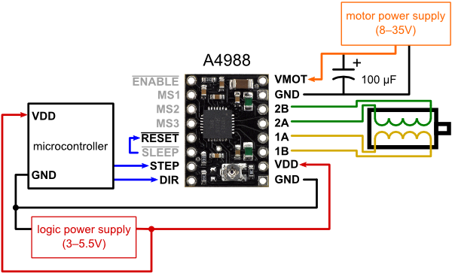

**Useful Pin Out Diagram for the Stepper Driver**

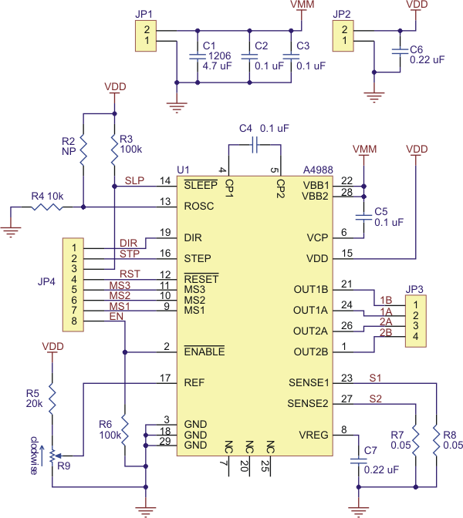

**Stepper Driver Schematic**

* Howard I-19-4202 Stepper Motors: <http://people.sinclair.edu/nickreeder/eet2261/datasheets/howard1_19_4202.pdf>



**Stepper Motor Wiring Diagram**



**Schematic**

* RAMPS board: <http://reprap.org/wiki/Arduino_Mega_Pololu_Shield>

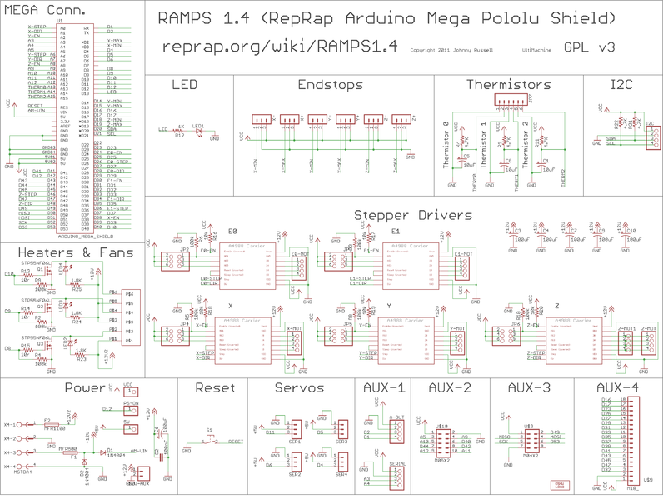

**Schematic**

* Teensy 3.1: https://www.pjrc.com/teensy/index.html

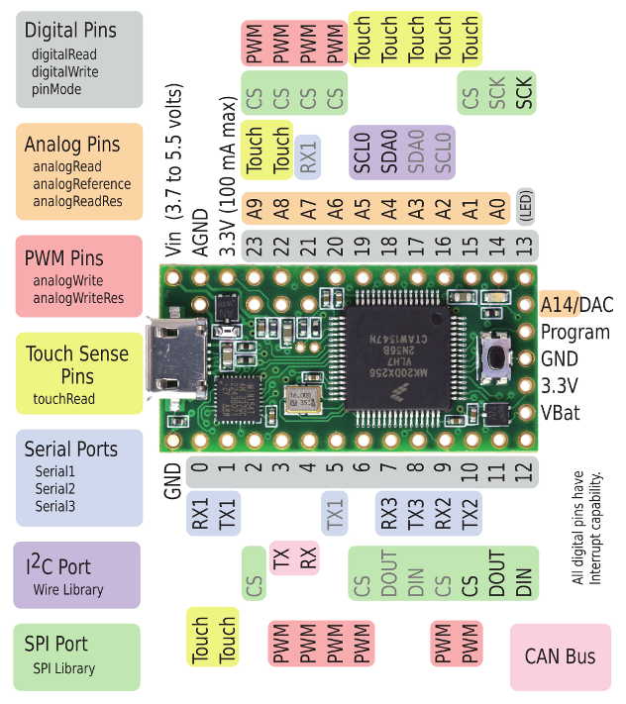

**Pin Assignments**

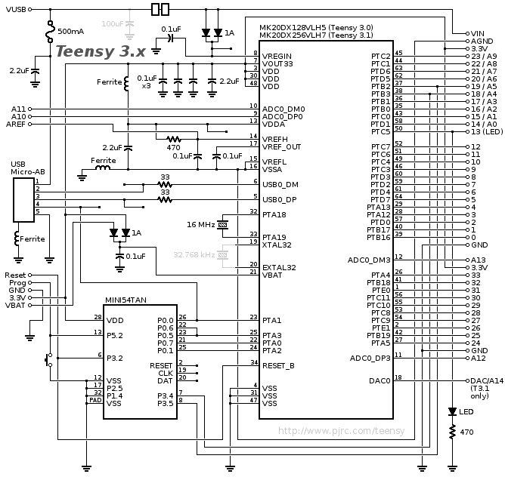

**Schematic**

* Example program: <https://www.pjrc.com/teensy/td_libs_AccelStepper.html>

Copy and paste the Example program into a new Arduino sketch and save the project. Make sure you save before compiling. You can comment out the Y and the Z axis if you just want to try out one stepper motor.